AIPP LAB 18
Name: VISHWAK NOMULA
Hall Ticket No.: 2503B05120
Date: 10/12/2025 (Week 7)
_____________________________________________
Completed this Assignment using VS – Gemini Al Integration.
Task 1:
Translate a Simple Program (Python → JavaScript)
CODE:
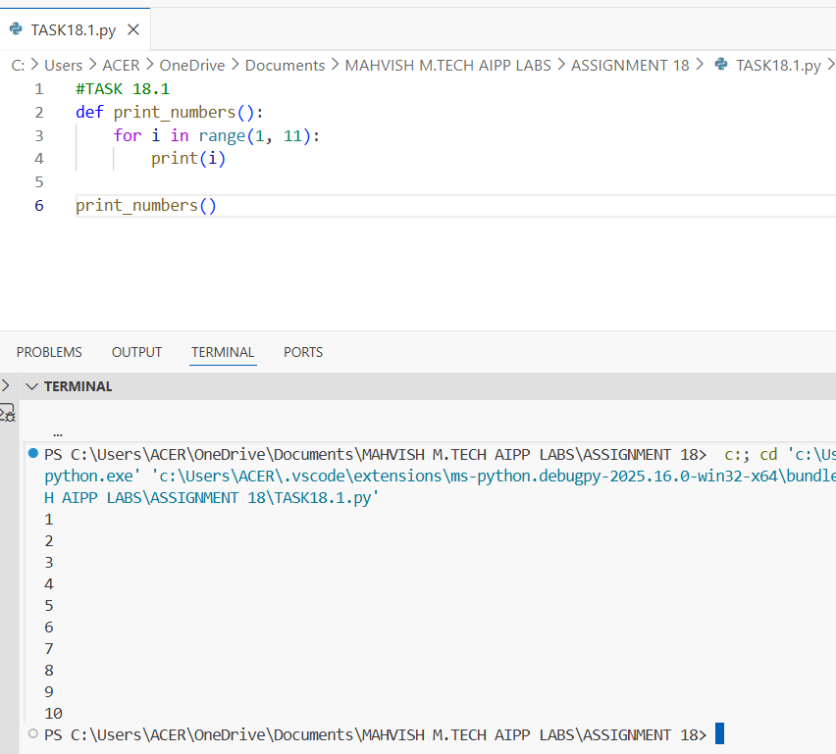
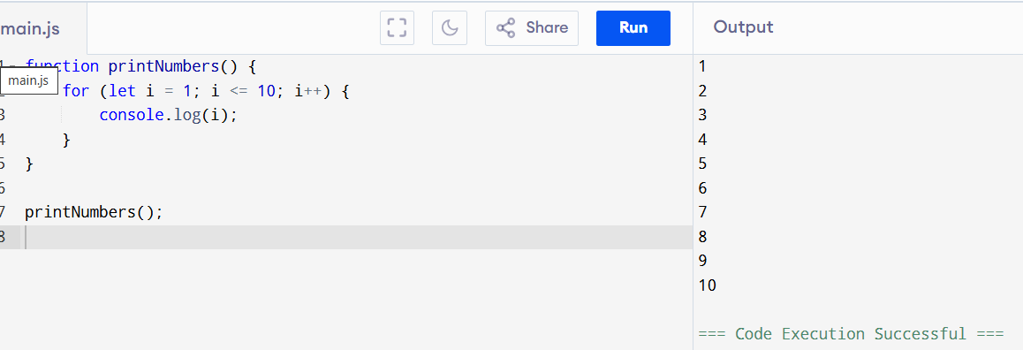
Task 2:
Convert Conditional Statements (Java → Python)
CODE:
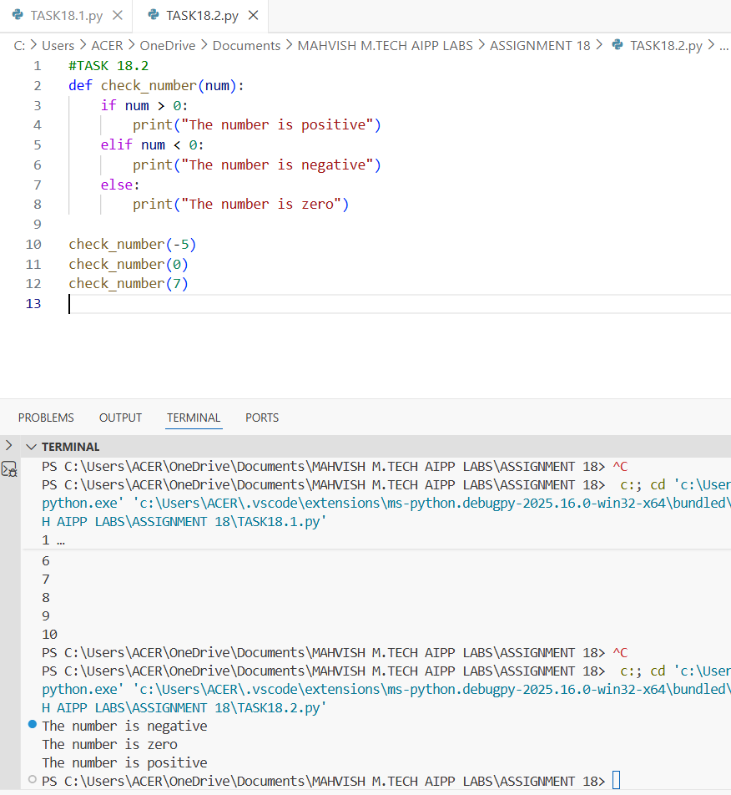

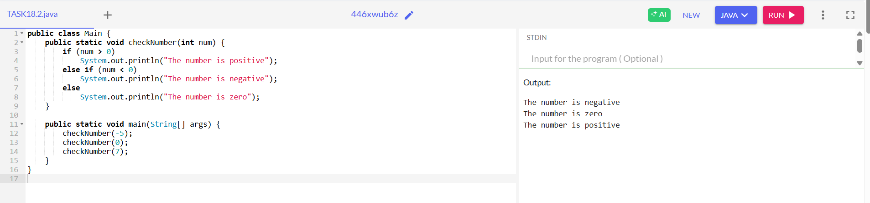
Task 3:
Translate Recursive Function (Python → C++)
CODE:
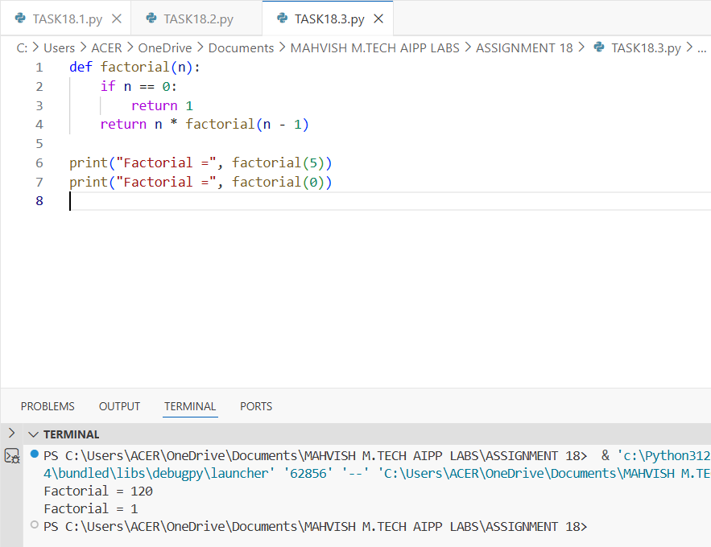
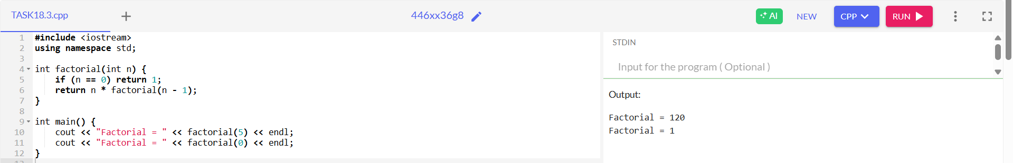
Task 4:
Data Structures with Functions (JavaScript → Python)
CODE:
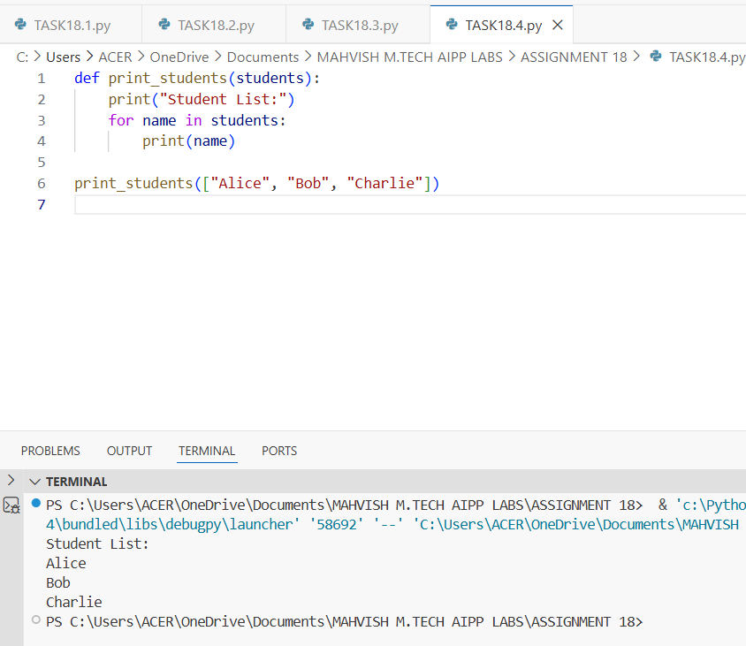
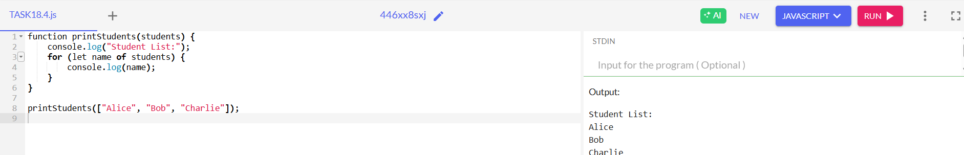

Task 5:
Class & Object Translation (Python → Java)
CODE:



